Test Case: tc002_SPX_Dev5_Crear_Requisicion_Spot_Con_FAD_Tipo_Cobro_CC
Step 1 - Enter username and password and click to button Enter : Credentials Entered
Image file-name: QC_Testing-tc002_SPX_Dev5_Crear_Requisicion_Spot_Con_FAD_Tipo_Cobro_CC-dic. 02 2025, 10 22 04 a. m.

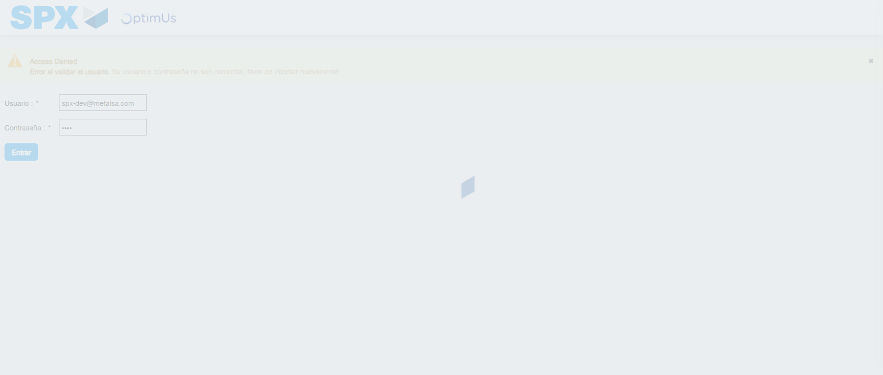Image file-name: QC_Testing-tc002_SPX_Dev5_Crear_Requisicion_Spot_Con_FAD_Tipo_Cobro_CC-dic. 02 2025, 10 22 05 a. m.

Step 2 - Select to UEN and Access to Spot Buy Requisitions : UEN Correctly selected and Correct access
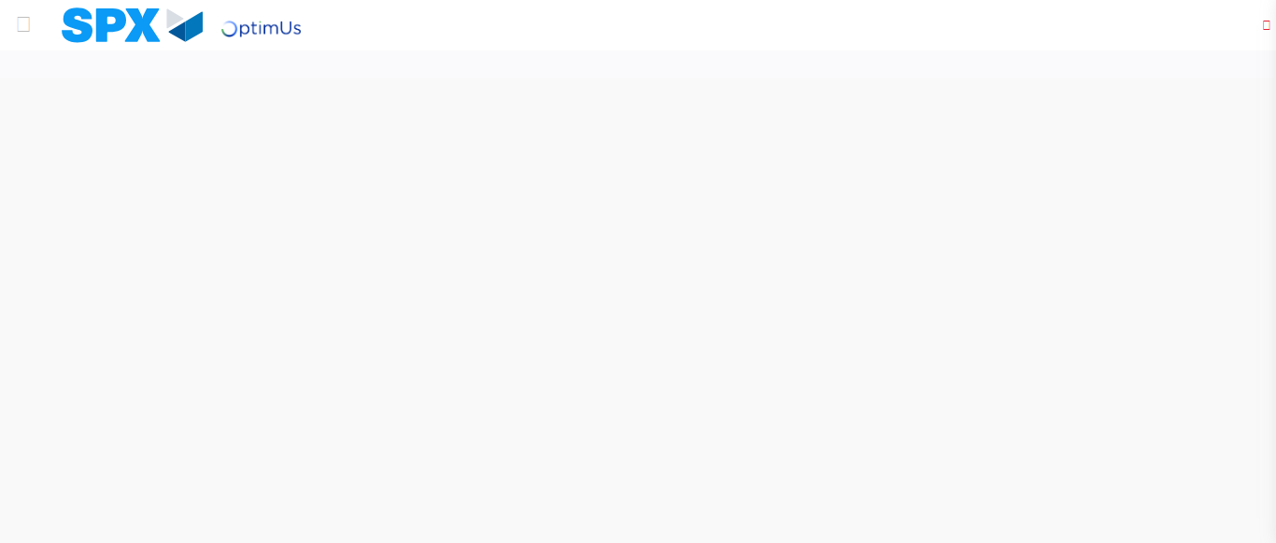Image file-name: QC_Testing-tc002_SPX_Dev5_Crear_Requisicion_Spot_Con_FAD_Tipo_Cobro_CC-dic. 02 2025, 10 22 09 a. m.

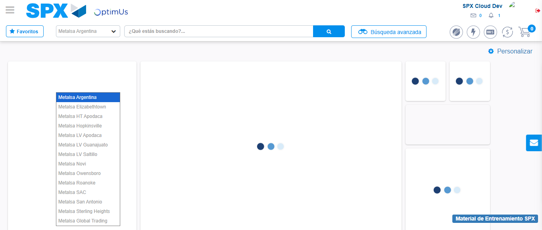Image file-name: QC_Testing-tc002_SPX_Dev5_Crear_Requisicion_Spot_Con_FAD_Tipo_Cobro_CC-dic. 02 2025, 10 22 10 a. m.

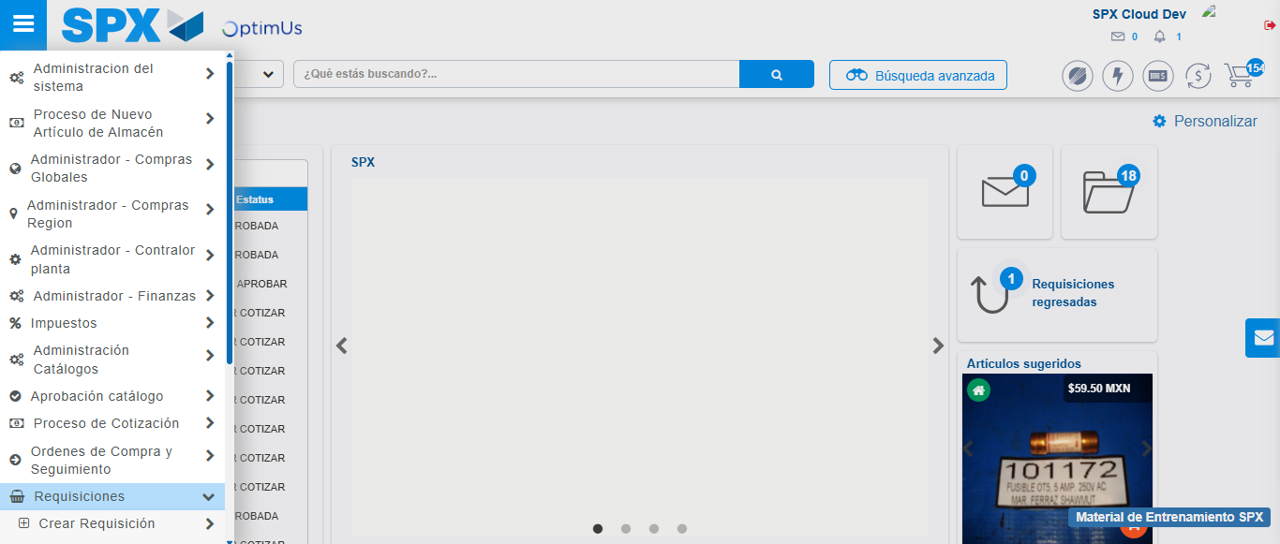Image file-name: QC_Testing-tc002_SPX_Dev5_Crear_Requisicion_Spot_Con_FAD_Tipo_Cobro_CC-dic. 02 2025, 10 22 11 a. m.

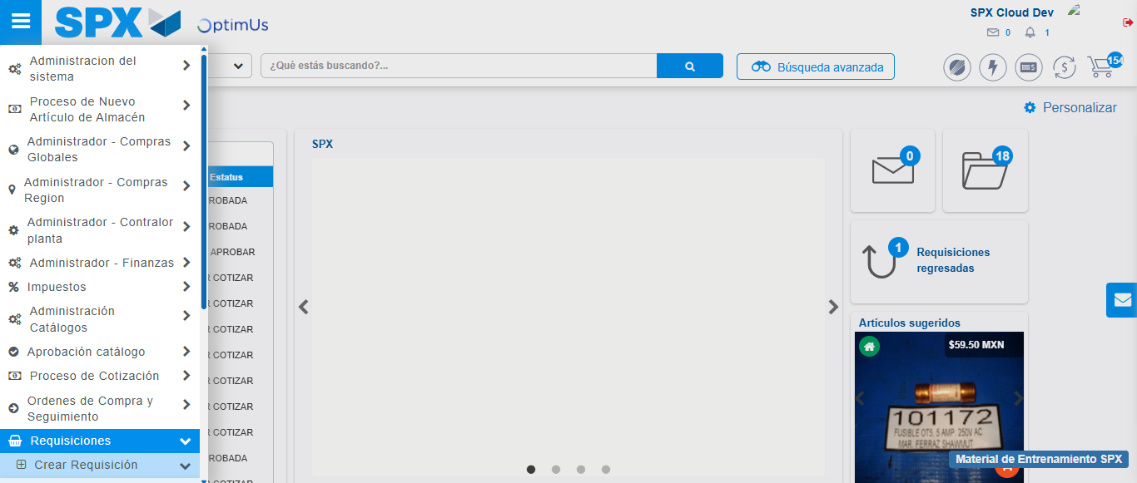Image file-name: QC_Testing-tc002_SPX_Dev5_Crear_Requisicion_Spot_Con_FAD_Tipo_Cobro_CC-dic. 02 2025, 10 22 12 a. m.

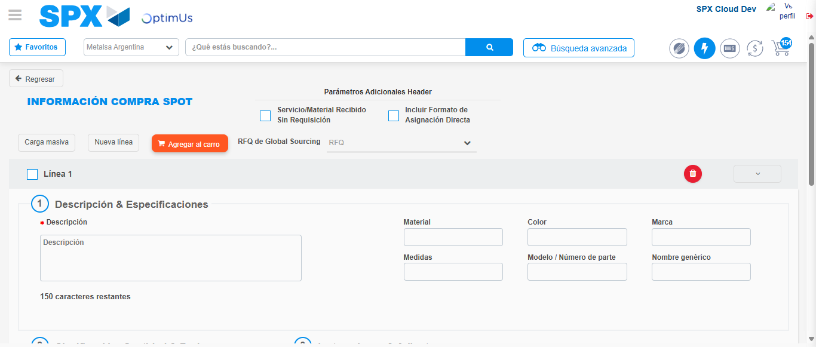Image file-name: QC_Testing-tc002_SPX_Dev5_Crear_Requisicion_Spot_Con_FAD_Tipo_Cobro_CC-dic. 02 2025, 10 22 15 a. m.

Step 3 - Add FAD to Requisition: FAD Successfully Added
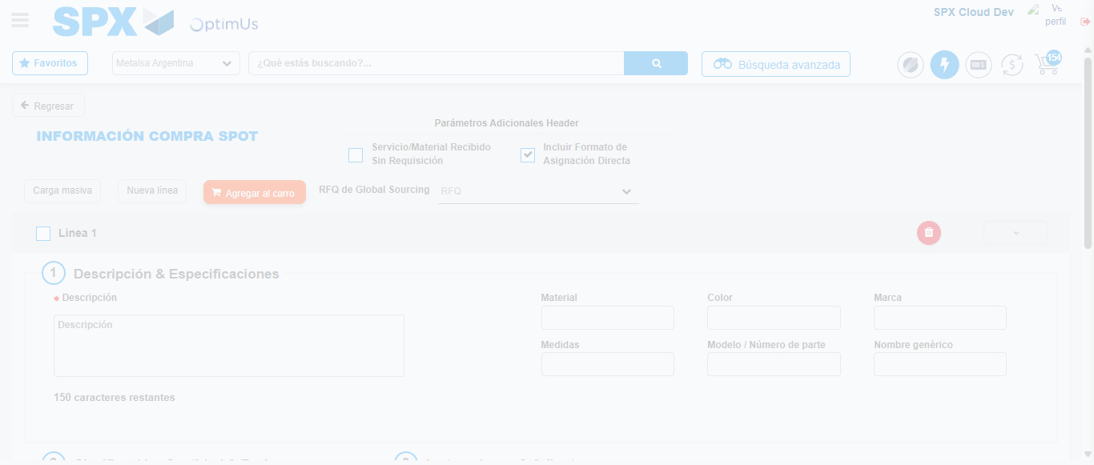Image file-name: QC_Testing-tc002_SPX_Dev5_Crear_Requisicion_Spot_Con_FAD_Tipo_Cobro_CC-dic. 02 2025, 10 22 16 a. m.

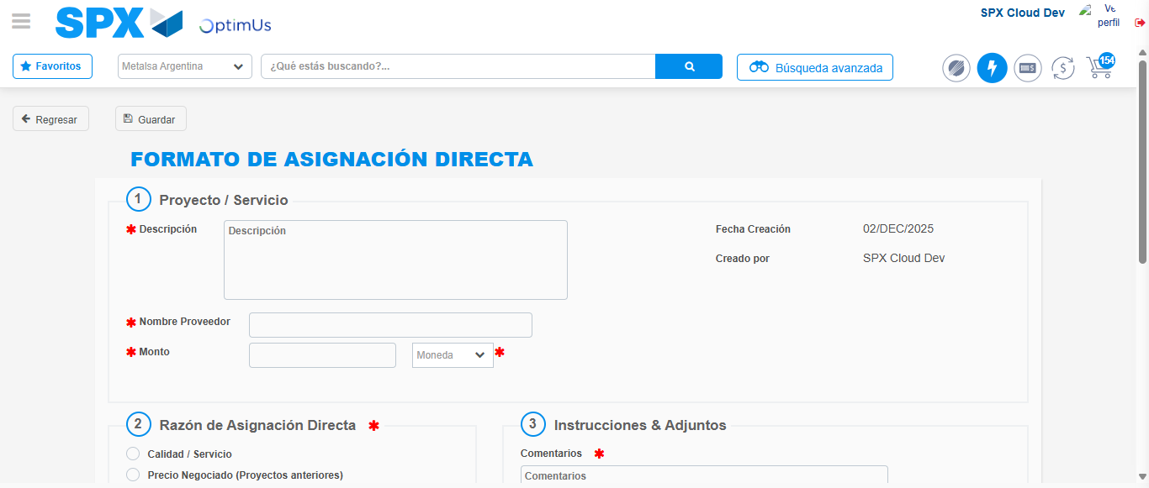Image file-name: QC_Testing-tc002_SPX_Dev5_Crear_Requisicion_Spot_Con_FAD_Tipo_Cobro_CC-dic. 02 2025, 10 22 19 a. m.

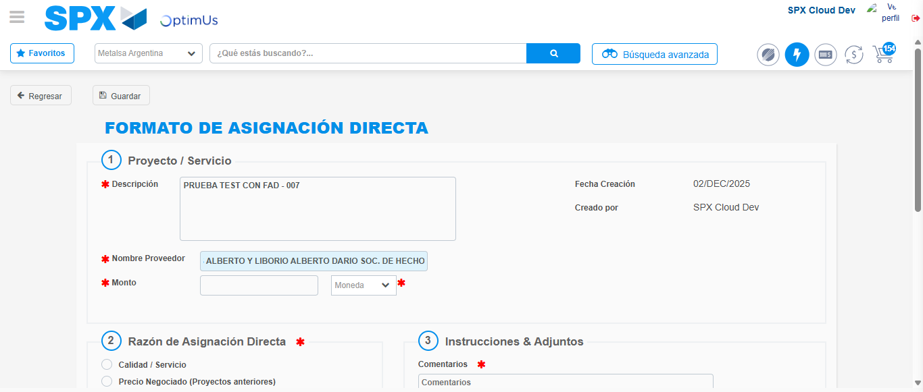Image file-name: QC_Testing-tc002_SPX_Dev5_Crear_Requisicion_Spot_Con_FAD_Tipo_Cobro_CC-dic. 02 2025, 10 22 20 a. m.

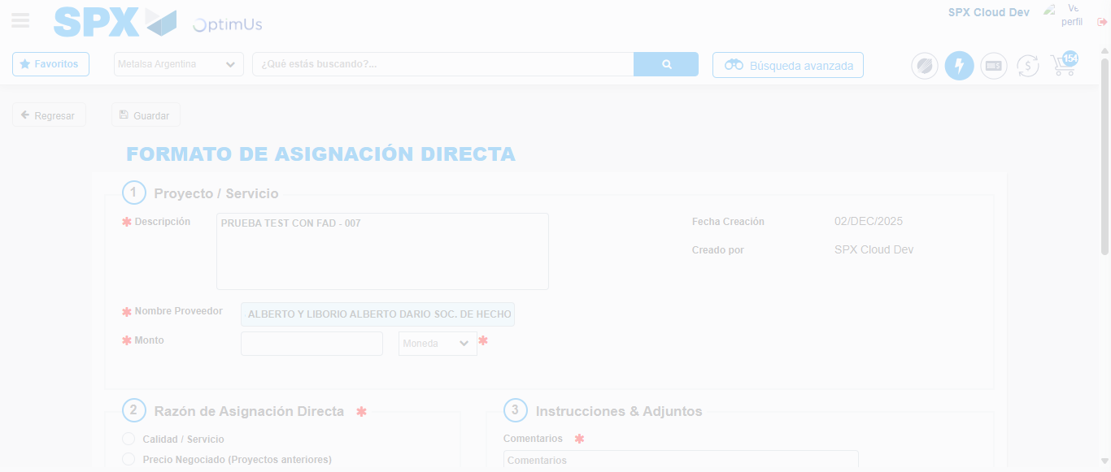Image file-name: QC_Testing-tc002_SPX_Dev5_Crear_Requisicion_Spot_Con_FAD_Tipo_Cobro_CC-dic. 02 2025, 10 22 23 a. m.

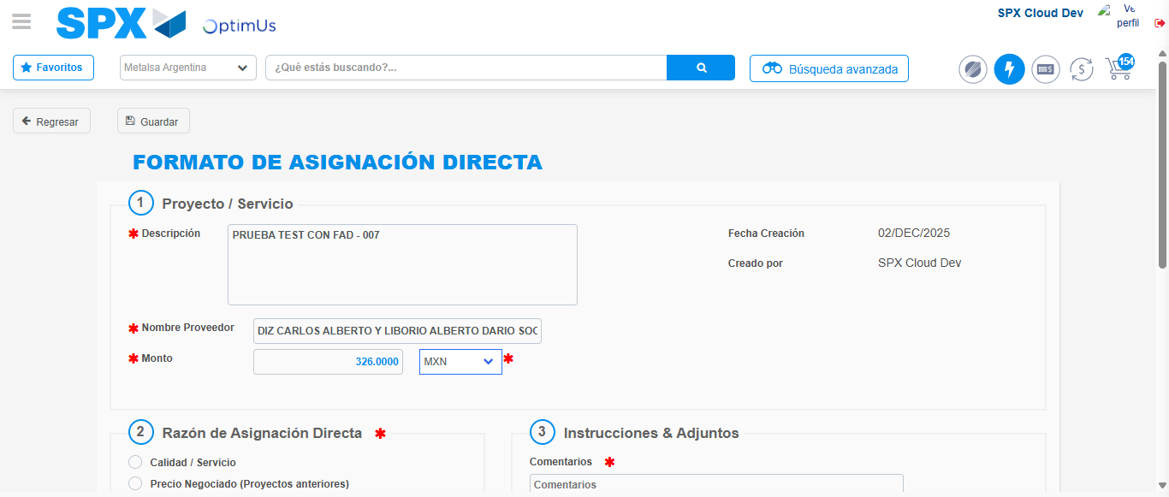Image file-name: QC_Testing-tc002_SPX_Dev5_Crear_Requisicion_Spot_Con_FAD_Tipo_Cobro_CC-dic. 02 2025, 10 22 27 a. m.

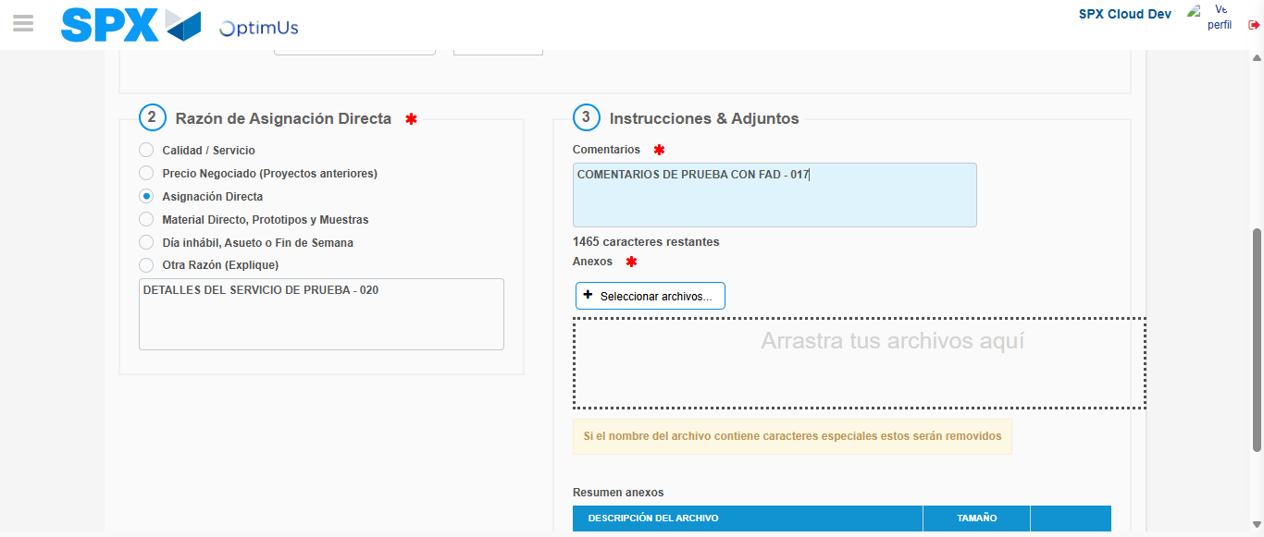Image file-name: QC_Testing-tc002_SPX_Dev5_Crear_Requisicion_Spot_Con_FAD_Tipo_Cobro_CC-dic. 02 2025, 10 22 31 a. m.

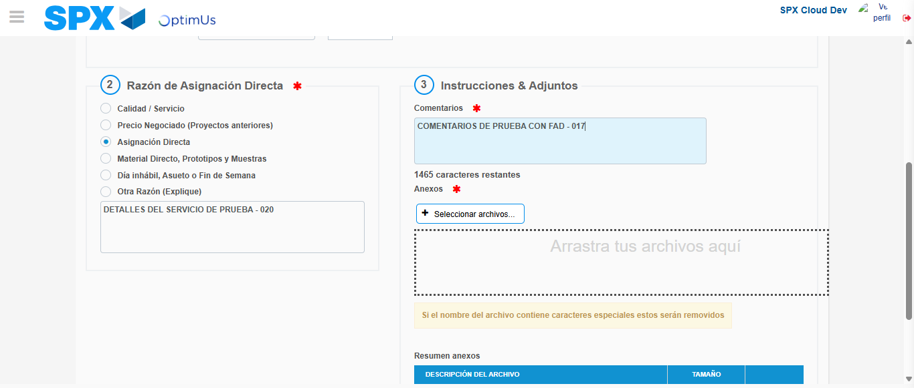Image file-name: QC_Testing-tc002_SPX_Dev5_Crear_Requisicion_Spot_Con_FAD_Tipo_Cobro_CC-dic. 02 2025, 10 22 34 a. m.

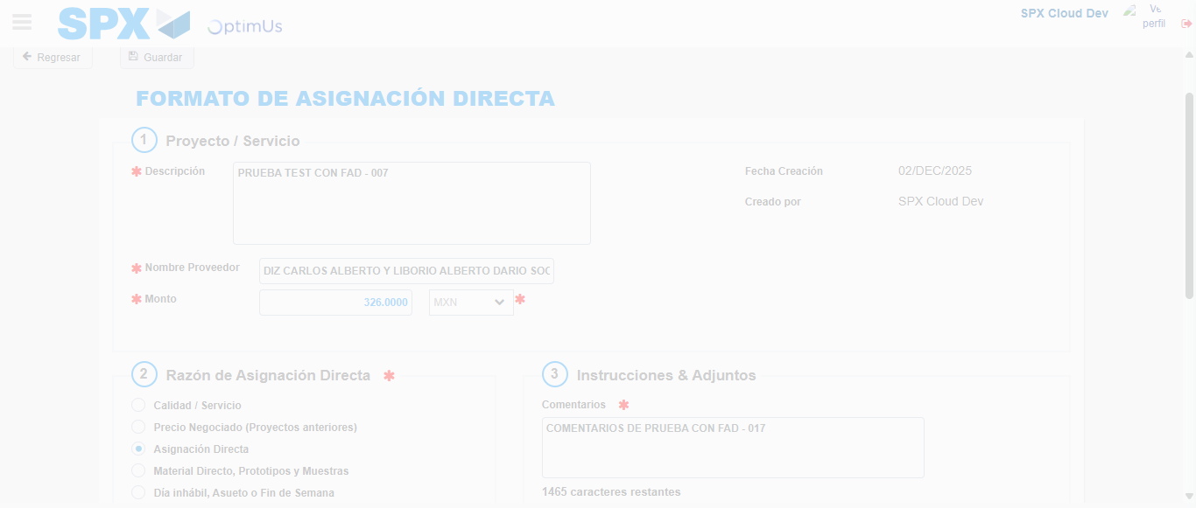Image file-name: QC_Testing-tc002_SPX_Dev5_Crear_Requisicion_Spot_Con_FAD_Tipo_Cobro_CC-dic. 02 2025, 10 22 35 a. m.

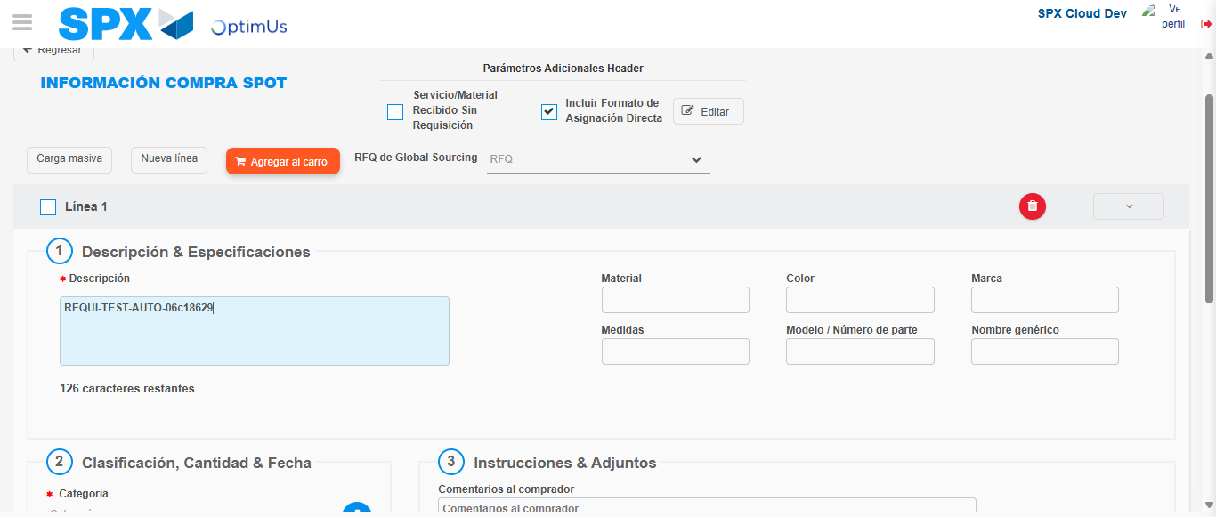Image file-name: QC_Testing-tc002_SPX_Dev5_Crear_Requisicion_Spot_Con_FAD_Tipo_Cobro_CC-dic. 02 2025, 10 22 38 a. m.

Step 4 - Data Capture Spot Buy Requisition: Data captured correctly
Image file-name: QC_Testing-tc002_SPX_Dev5_Crear_Requisicion_Spot_Con_FAD_Tipo_Cobro_CC-dic. 02 2025, 10 22 16 a. m.

Image file-name: QC_Testing-tc002_SPX_Dev5_Crear_Requisicion_Spot_Con_FAD_Tipo_Cobro_CC-dic. 02 2025, 10 22 19 a. m.

Image file-name: QC_Testing-tc002_SPX_Dev5_Crear_Requisicion_Spot_Con_FAD_Tipo_Cobro_CC-dic. 02 2025, 10 22 38 a. m.

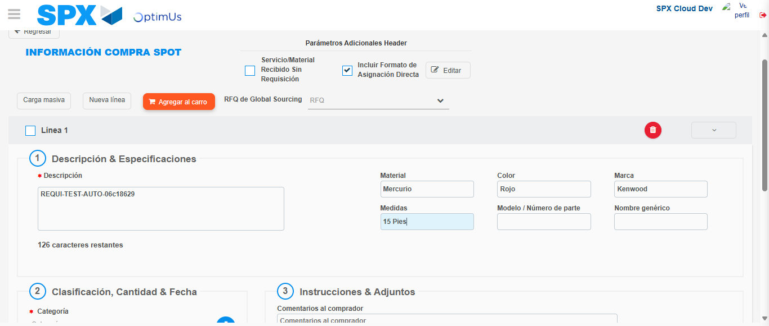Image file-name: QC_Testing-tc002_SPX_Dev5_Crear_Requisicion_Spot_Con_FAD_Tipo_Cobro_CC-dic. 02 2025, 10 22 39 a. m.

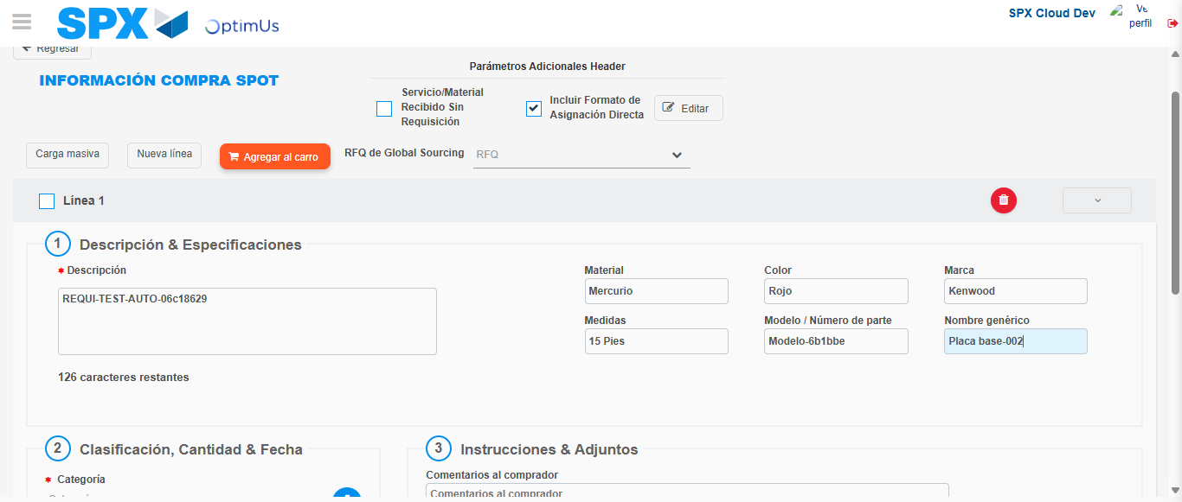Image file-name: QC_Testing-tc002_SPX_Dev5_Crear_Requisicion_Spot_Con_FAD_Tipo_Cobro_CC-dic. 02 2025, 10 22 40 a. m.

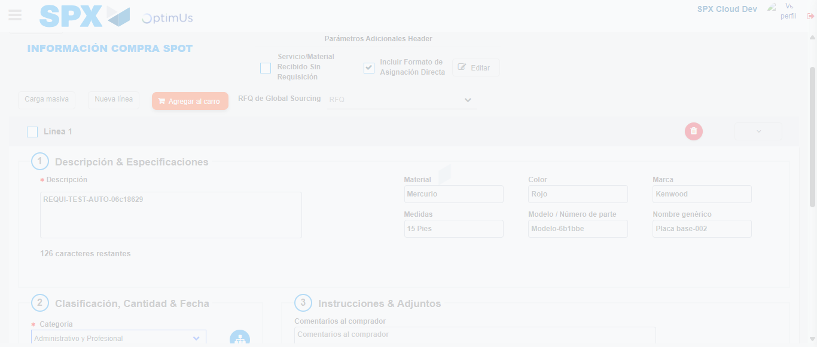Image file-name: QC_Testing-tc002_SPX_Dev5_Crear_Requisicion_Spot_Con_FAD_Tipo_Cobro_CC-dic. 02 2025, 10 22 41 a. m.

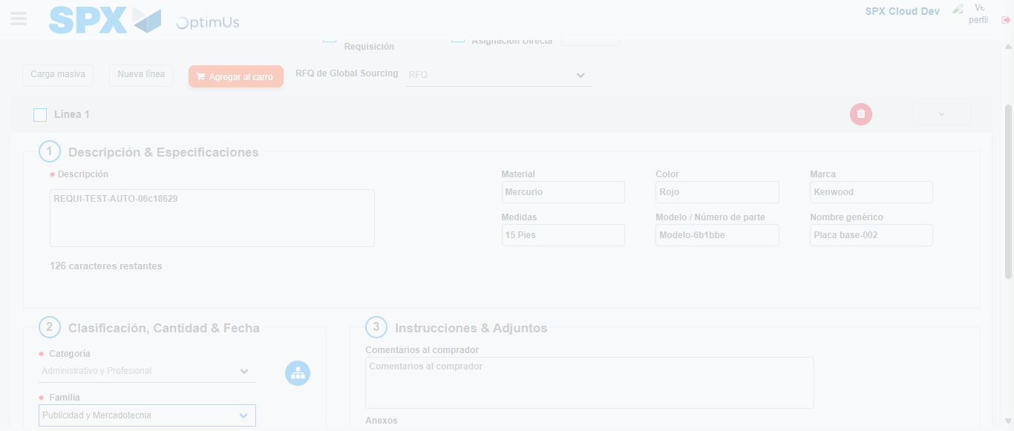Image file-name: QC_Testing-tc002_SPX_Dev5_Crear_Requisicion_Spot_Con_FAD_Tipo_Cobro_CC-dic. 02 2025, 10 22 42 a. m.

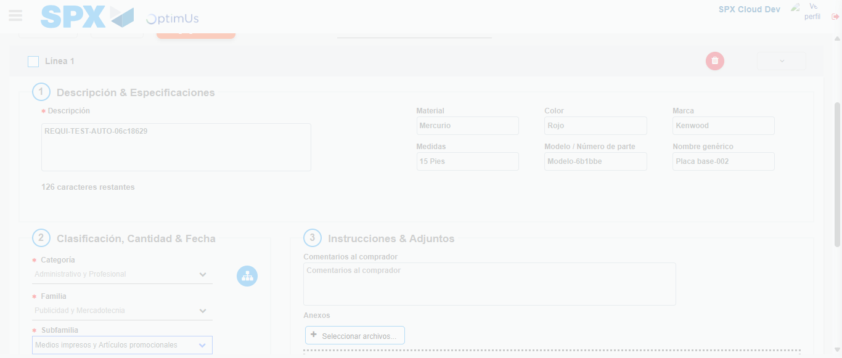Image file-name: QC_Testing-tc002_SPX_Dev5_Crear_Requisicion_Spot_Con_FAD_Tipo_Cobro_CC-dic. 02 2025, 10 22 43 a. m.

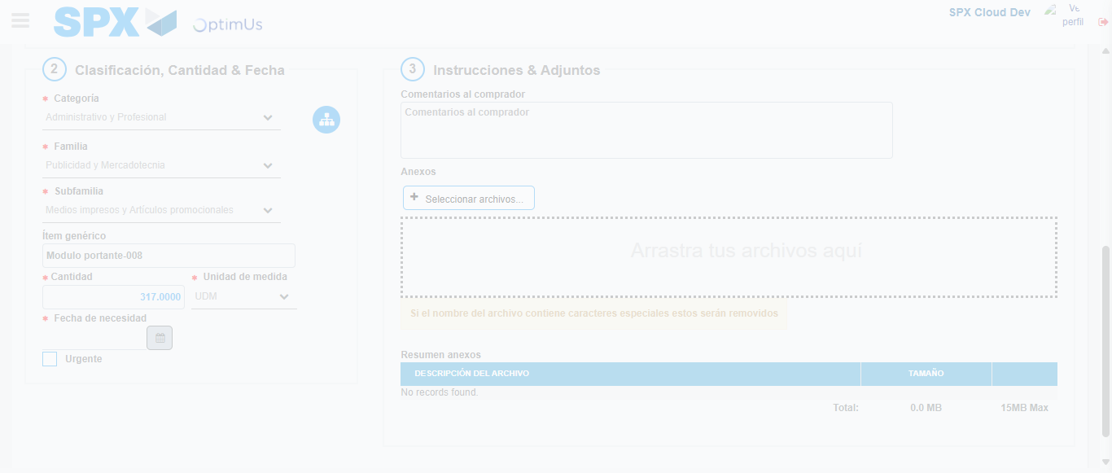Image file-name: QC_Testing-tc002_SPX_Dev5_Crear_Requisicion_Spot_Con_FAD_Tipo_Cobro_CC-dic. 02 2025, 10 22 44 a. m.

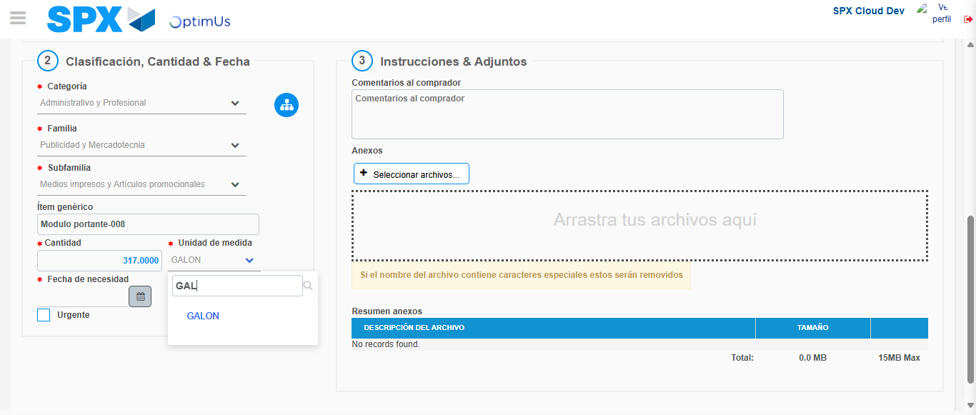Image file-name: QC_Testing-tc002_SPX_Dev5_Crear_Requisicion_Spot_Con_FAD_Tipo_Cobro_CC-dic. 02 2025, 10 22 45 a. m.

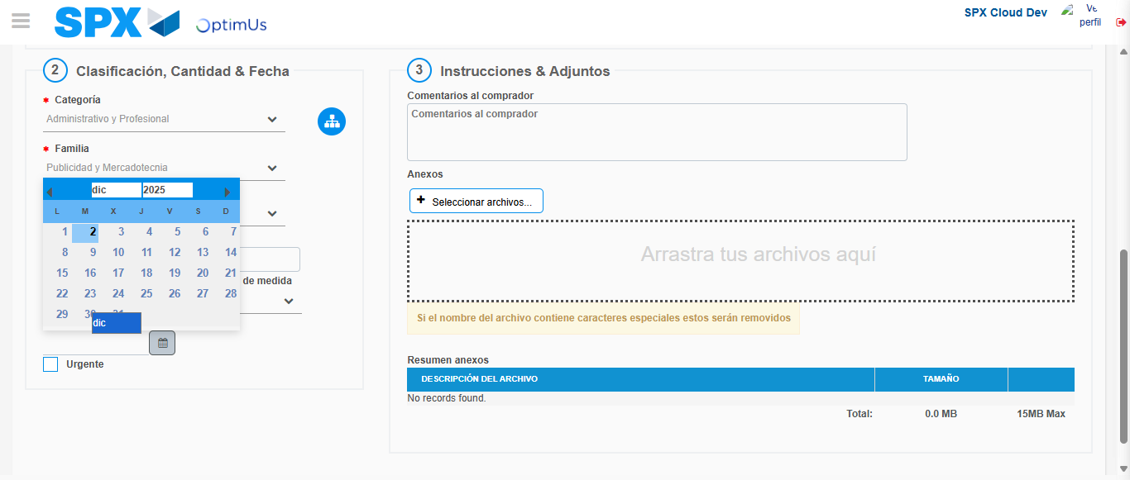Image file-name: QC_Testing-tc002_SPX_Dev5_Crear_Requisicion_Spot_Con_FAD_Tipo_Cobro_CC-dic. 02 2025, 10 22 46 a. m.

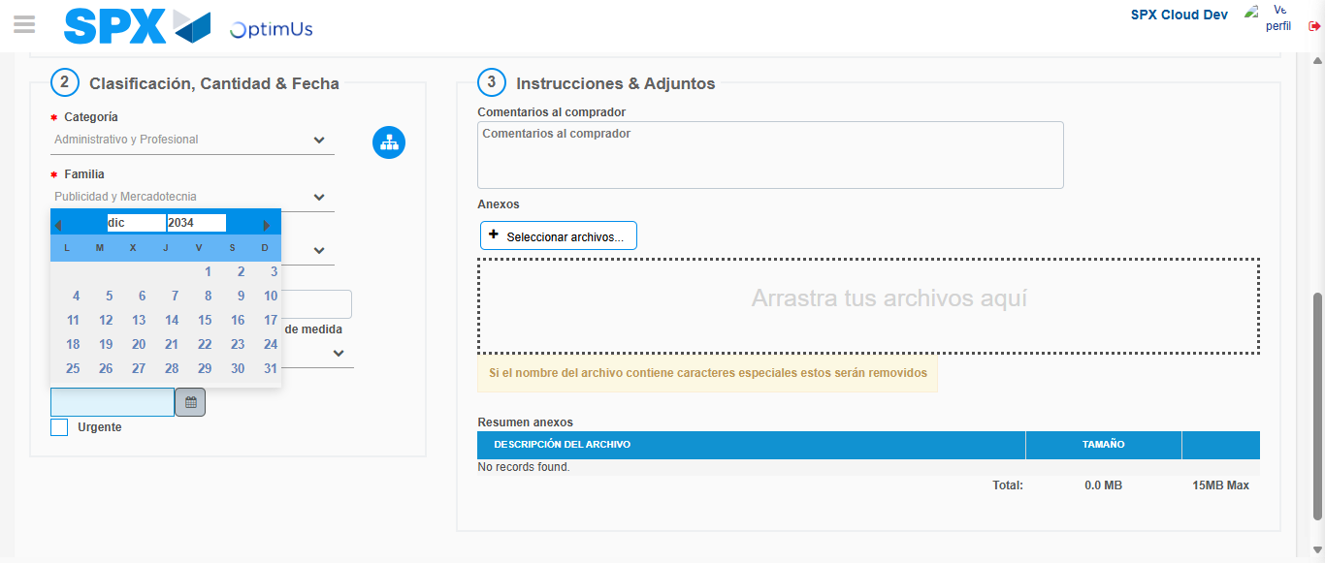Image file-name: QC_Testing-tc002_SPX_Dev5_Crear_Requisicion_Spot_Con_FAD_Tipo_Cobro_CC-dic. 02 2025, 10 22 47 a. m.

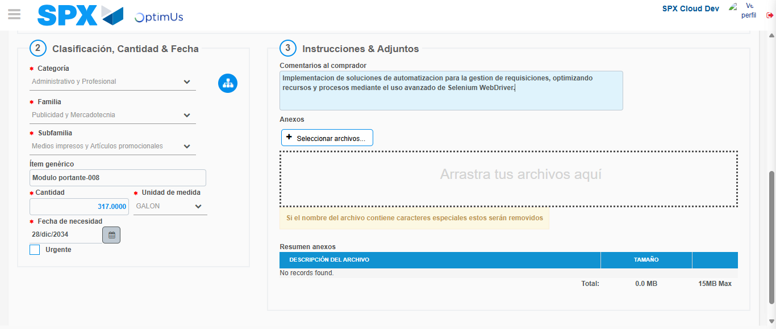Image file-name: QC_Testing-tc002_SPX_Dev5_Crear_Requisicion_Spot_Con_FAD_Tipo_Cobro_CC-dic. 02 2025, 10 22 48 a. m.

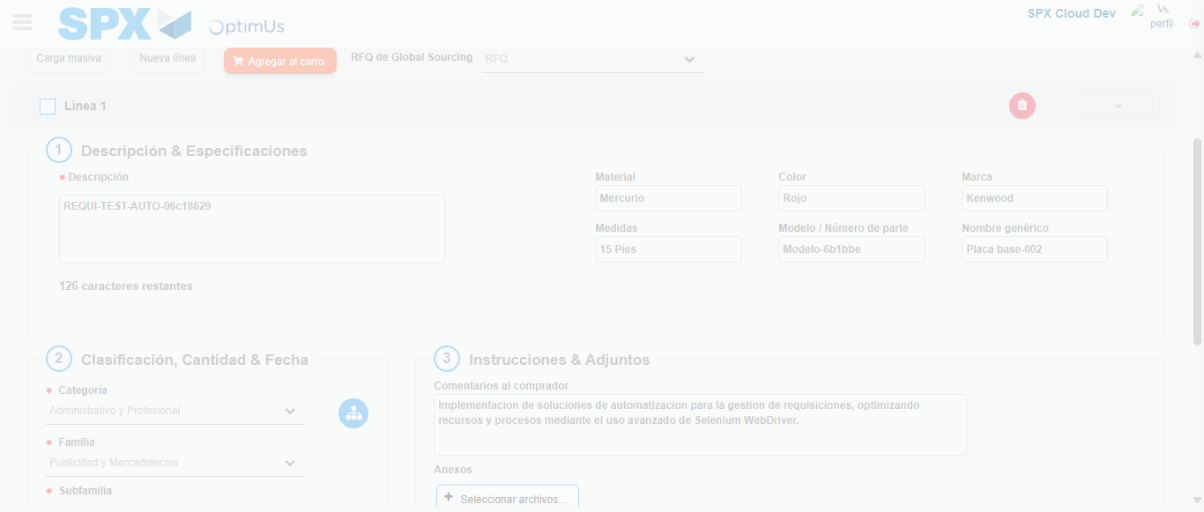Image file-name: QC_Testing-tc002_SPX_Dev5_Crear_Requisicion_Spot_Con_FAD_Tipo_Cobro_CC-dic. 02 2025, 10 22 49 a. m.

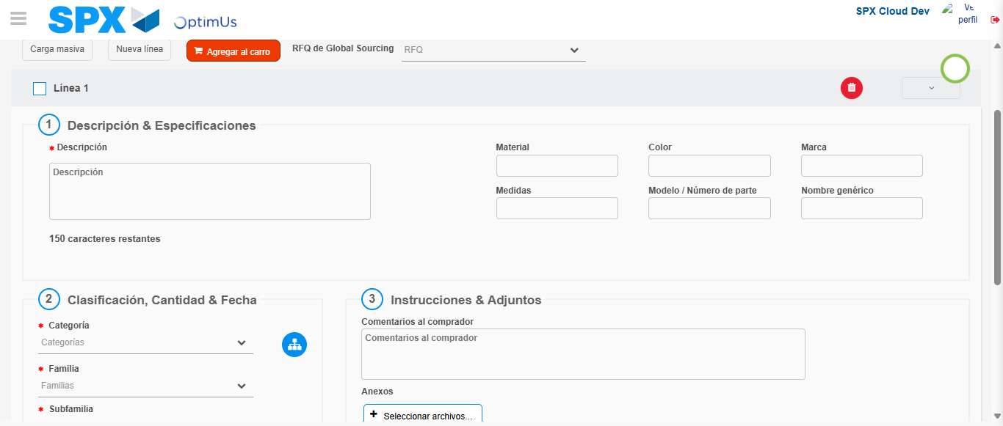Image file-name: QC_Testing-tc002_SPX_Dev5_Crear_Requisicion_Spot_Con_FAD_Tipo_Cobro_CC-dic. 02 2025, 10 22 53 a. m.

Step 5 - Select to Requisition: Requisition Correctly selected
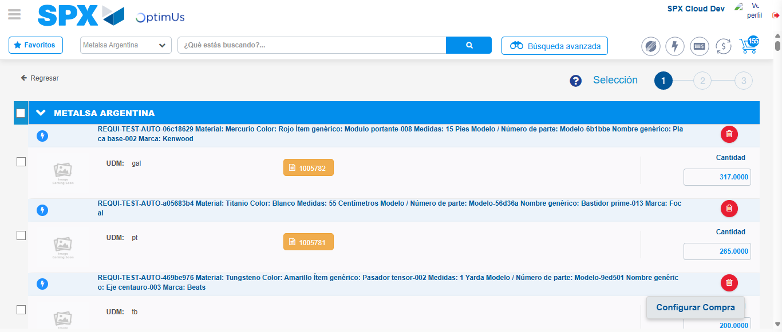Image file-name: QC_Testing-tc002_SPX_Dev5_Crear_Requisicion_Spot_Con_FAD_Tipo_Cobro_CC-dic. 02 2025, 10 23 03 a. m.

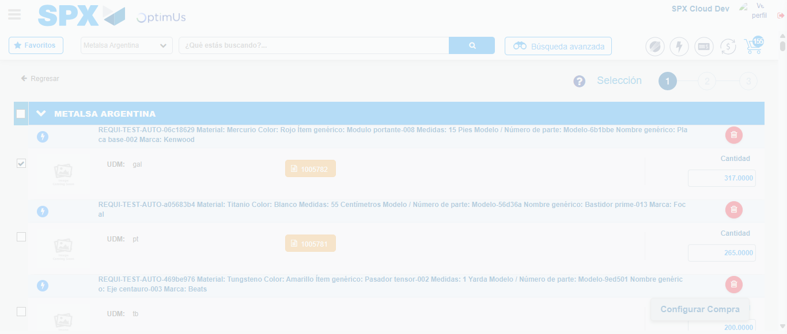Image file-name: QC_Testing-tc002_SPX_Dev5_Crear_Requisicion_Spot_Con_FAD_Tipo_Cobro_CC-dic. 02 2025, 10 23 04 a. m.

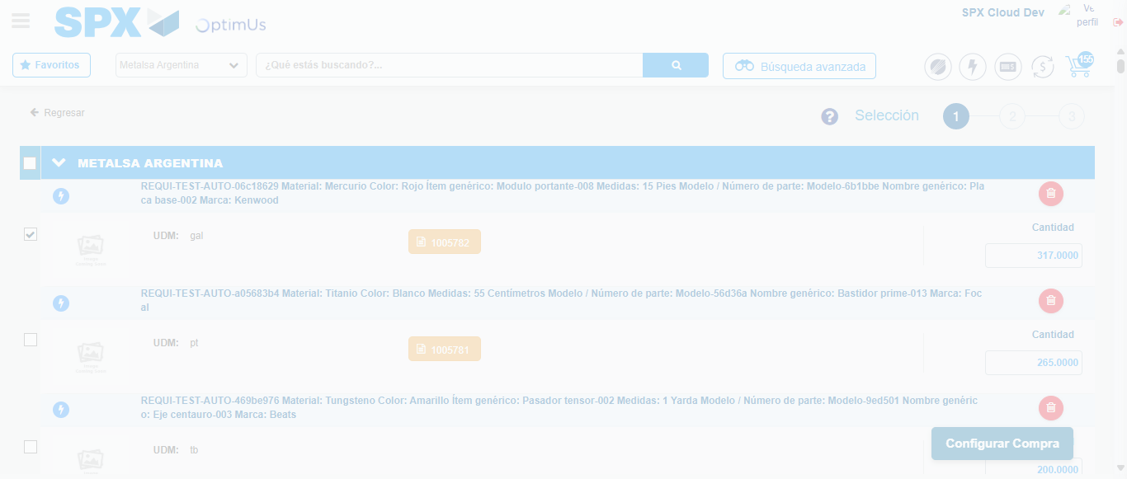Image file-name: QC_Testing-tc002_SPX_Dev5_Crear_Requisicion_Spot_Con_FAD_Tipo_Cobro_CC-dic. 02 2025, 10 23 07 a. m.

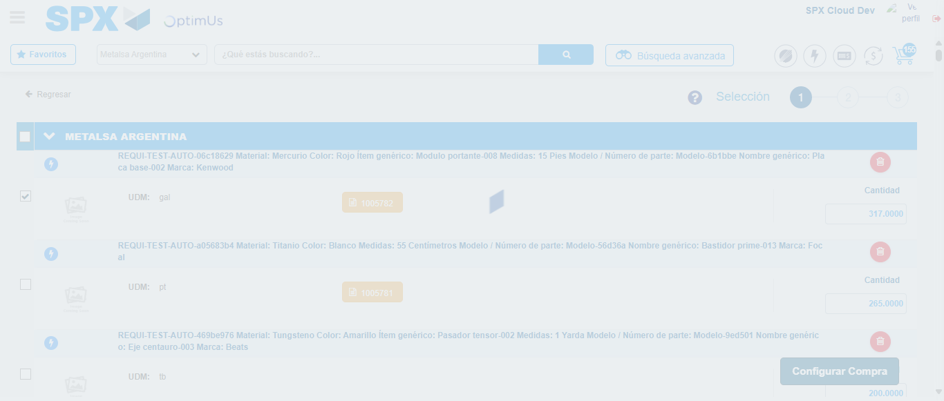Image file-name: QC_Testing-tc002_SPX_Dev5_Crear_Requisicion_Spot_Con_FAD_Tipo_Cobro_CC-dic. 02 2025, 10 23 08 a. m.

Step 6 - Select Type Account For Requisition: Type Account Correctly selected
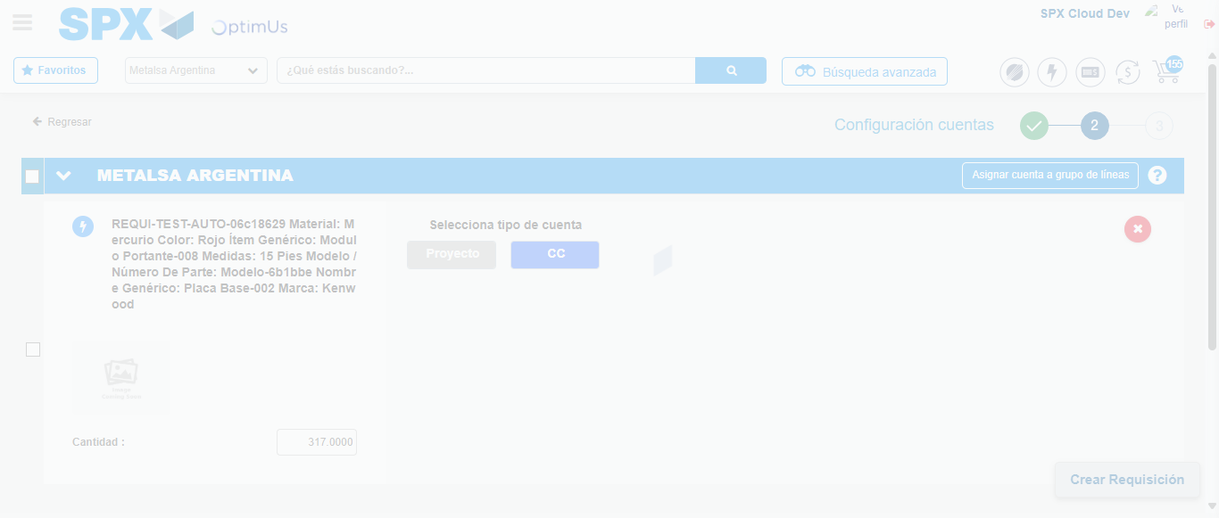Image file-name: QC_Testing-tc002_SPX_Dev5_Crear_Requisicion_Spot_Con_FAD_Tipo_Cobro_CC-dic. 02 2025, 10 23 10 a. m.

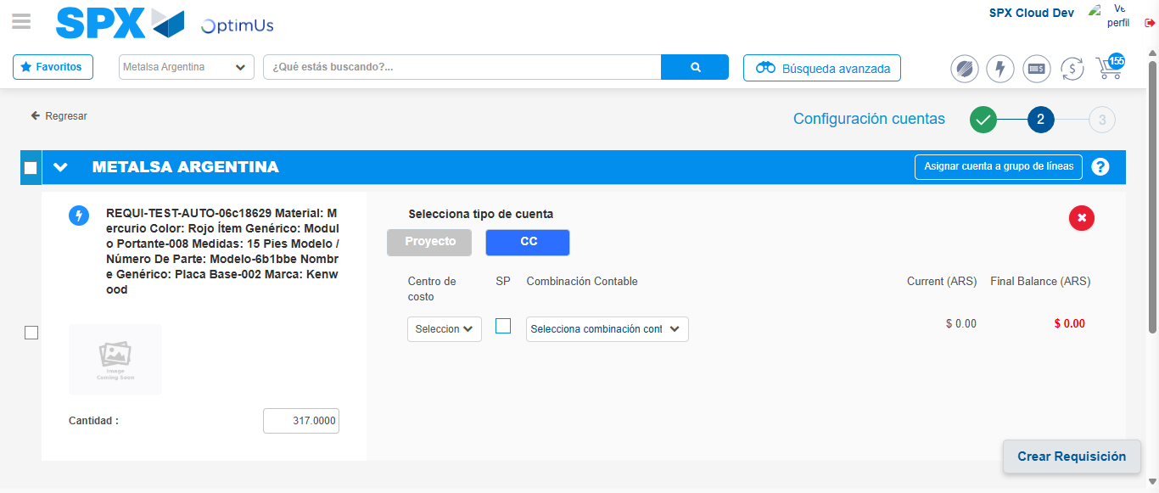Image file-name: QC_Testing-tc002_SPX_Dev5_Crear_Requisicion_Spot_Con_FAD_Tipo_Cobro_CC-dic. 02 2025, 10 23 13 a. m.

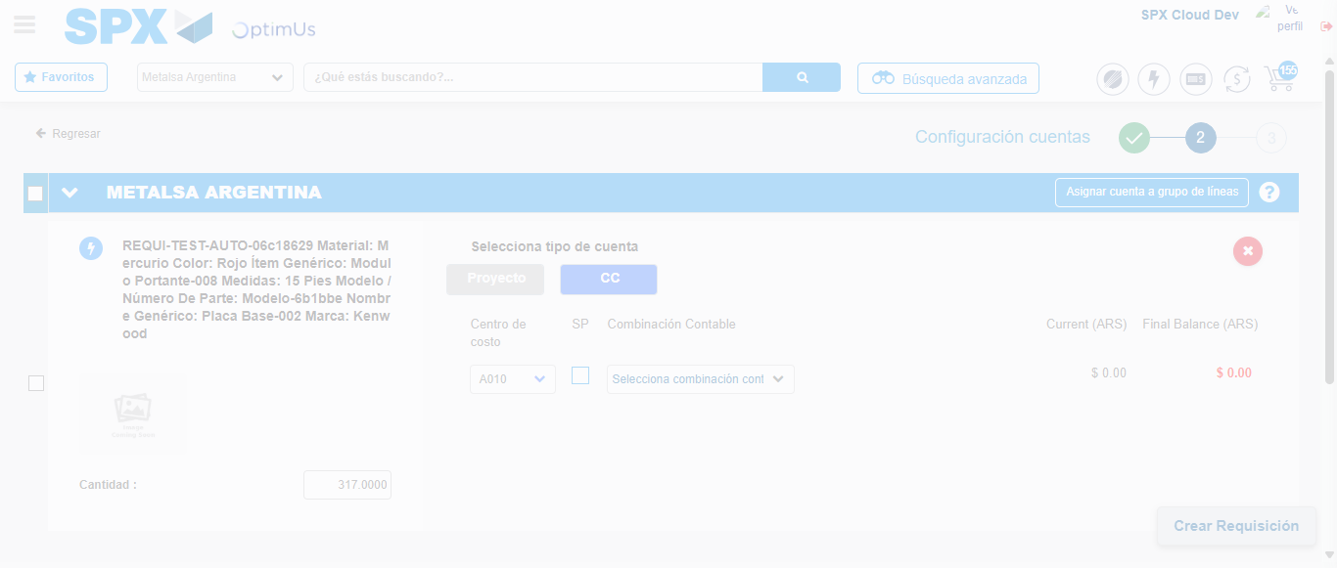Image file-name: QC_Testing-tc002_SPX_Dev5_Crear_Requisicion_Spot_Con_FAD_Tipo_Cobro_CC-dic. 02 2025, 10 23 17 a. m.

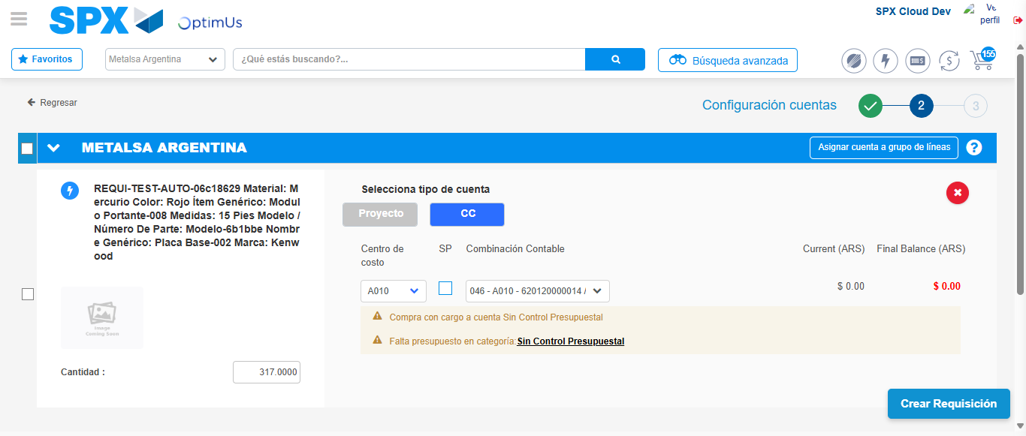Image file-name: QC_Testing-tc002_SPX_Dev5_Crear_Requisicion_Spot_Con_FAD_Tipo_Cobro_CC-dic. 02 2025, 10 23 20 a. m.

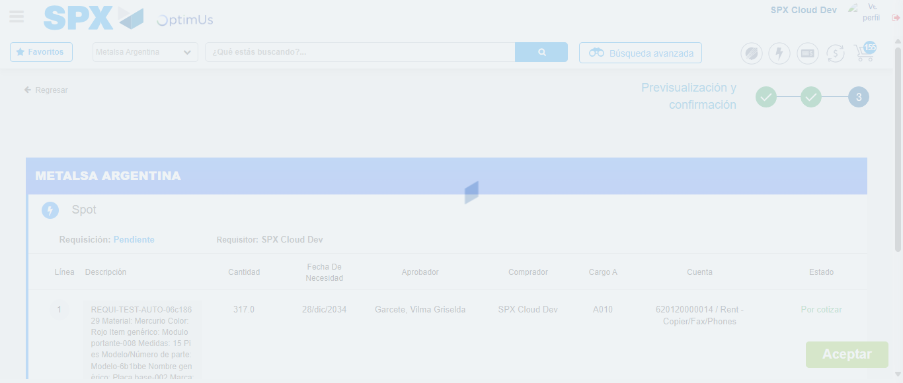Image file-name: QC_Testing-tc002_SPX_Dev5_Crear_Requisicion_Spot_Con_FAD_Tipo_Cobro_CC-dic. 02 2025, 10 23 21 a. m.

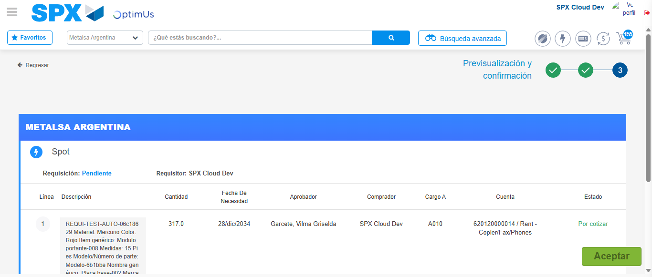Image file-name: QC_Testing-tc002_SPX_Dev5_Crear_Requisicion_Spot_Con_FAD_Tipo_Cobro_CC-dic. 02 2025, 10 23 24 a. m.

Step 7 - Accept to Requisition: Requisition Accepted
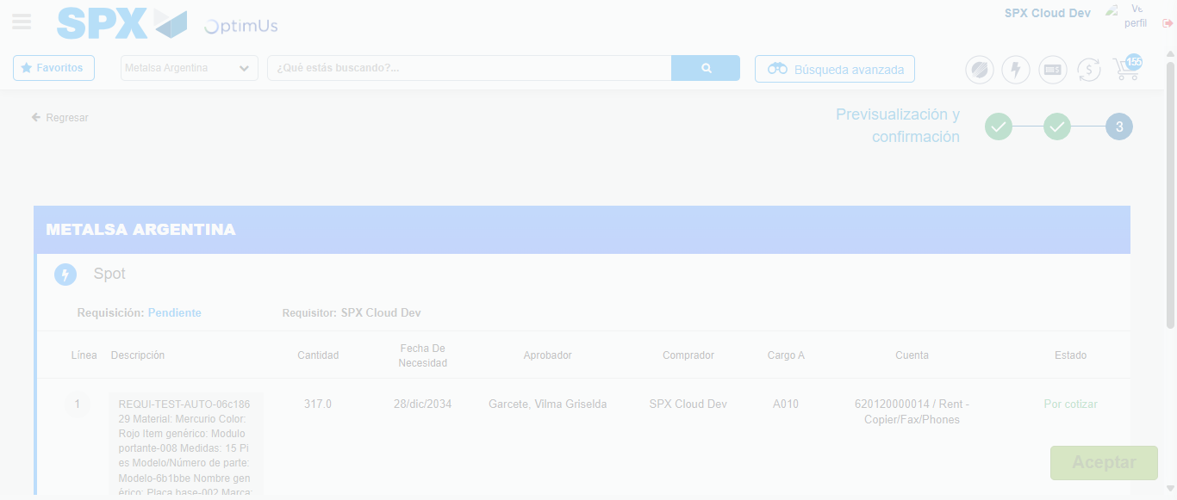Image file-name: QC_Testing-tc002_SPX_Dev5_Crear_Requisicion_Spot_Con_FAD_Tipo_Cobro_CC-dic. 02 2025, 10 23 25 a. m.

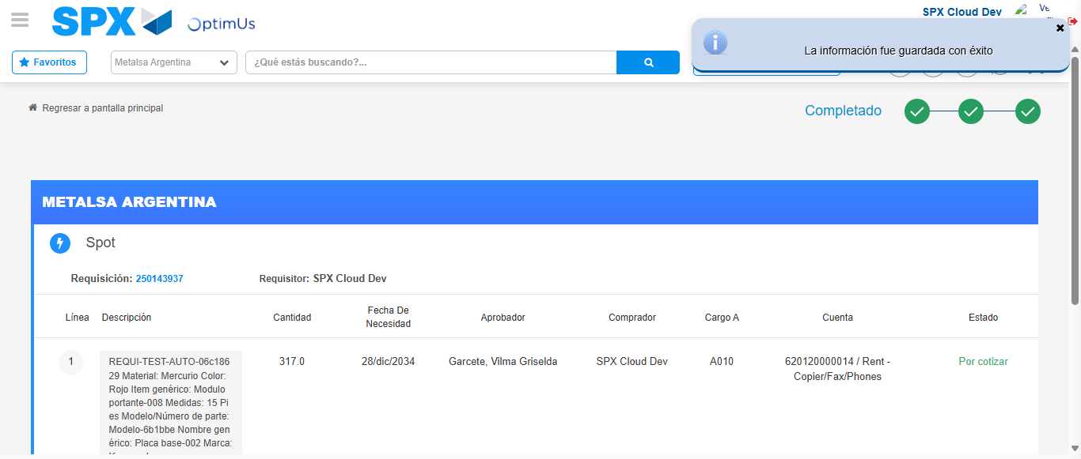Image file-name: QC_Testing-tc002_SPX_Dev5_Crear_Requisicion_Spot_Con_FAD_Tipo_Cobro_CC-dic. 02 2025, 10 23 28 a. m.

